Handout 2: Readings

Reading 1) Earthworks at Cold Harbor
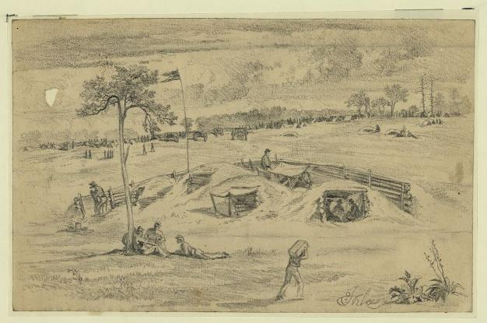
Forbes, Edwin. The Battle of Cold Harbor (Bomb Proofs). June 8, 1864. Library of Congress.
The following is a dispatch from John A. Brady, a soldier in the Union Army 18th Corps, published in the New York Herald June 7, 1864:
“A NEW STYLE OF INTRENCHING [sic] TOOLS. During the day the fire on the field in front of our line of battle was so excessively hot that the skirmishers resorted to a novel plan for throwing up intrenchments. Every man went to work with tin cup or plate, and dug a hole in the ground sufficiently large to burrow into, and these impromptu works, slight as they might seem, were impregnable to every assault of the enemy.”
These “intrenchments” or “earthworks” were large mounds of earth that acted as protective barriers from gun and mortar fire. As Brady narrates, soldiers dug long trenches and piled the dirt into mounds of earth on one side. They could then stationed themselves within the trenches behind these makeshift walls.
The soldiers may have camped at Cold Harbor for only a few weeks but the their efforts made a lasting impression on the landscape. Today visitors to the battlefield can see the earthworks that still stand as a reminder of the men who fought and died there centuries ago.
These earthworks are useful for archeologists who use material culture, or the objects people leave behind, to understand more about the past. They analyze artifacts, features, and the landscape of a site to interpret the events that occurred there. Features are the man-made, non-portable aspects of a site such as hearths, trash pits, or building walls. The Cold Harbor earthworks are an example of archeological features. By ‘reading’ the modified landscape, archeologists can understand how soldiers positioned and defended themselves during the battle.

Reading 2) Daily Life of a Soldier
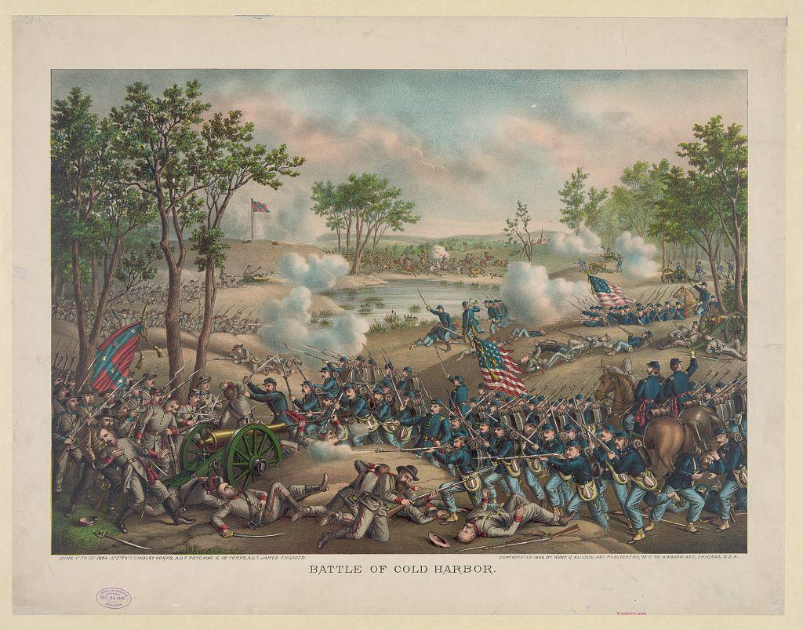
Kurz & Allison. “Battle of Cold Harbor.” C. December 24, 1888. Library of Congress.

George Philip Clark was a Confederate soldier who fought at the Battle of Cold Harbor. These are the entries he wrote in his diary between May 28 and June 5, 1864:

1st June 1864. 9 o’clock. Orders to move down the line again this morning. Our Corp has gotten on the extreme right of Lee’s Army and connected with the left of Beauregard’s forces which have come from the south side of Richmond. We marched about a mile and formed our line of battle here. We found no fortifications. We went to work immediately erecting some works. We worked the remainder of the day on them. We made splendid fortifications for the working utensils we had. Our company only had one spade and a hoe and some wooden shovels we made out of planks. The enemy attacked our lines this evening on our right near Cold Harbor on the Peninsular. The Yanks charges our lines several times and were repulsed with heavy loss. Night closed and with it the fight. We slept the remainder of the night but did not sleep much as we were aroused up several times thinking the enemy were advancing. Finding it to be false we would go back to bed again.

2nd June 1864. The day has been passing off quietly, more so than we expected. Some heavy skirmishing on the lines. We are expecting a fight at any moment. We are lying behind our works waiting for them to come. The men are all in fine spirits and anxious for the Yankees to advance on our fortifications. We get plenty of rations, half pound meat per day and plenty of bread, some sugar, coffee, and rice. The enemy attacked our left this evening in front of Ewell and Hill. They were repulsed. Ewell turned their right flank capturing five hundred prisoners. Our loss small. The enemy are still in the vicinity of Cold Harbor.

3rd June 1864. Heavy skirmishing on the lines this morn. I was detailed to take 10 men from my company to reinforce Pickett’s line. One man killed from our regiment, Sergt. Blaaky of Co. “F”. The enemy attacked our right again this evening in the vicinity of Cold Harbor. We still hold our position. They have not attacked our front yet. We had a light fall of rain to-day.

June 4th 1864. We still remain in our positions. Nothing of interest to-day. Night, the enemy has attacked our right again but was repulsed with heavy loss. All quiet in our front.

5th June 1864. Raining some to-day, the day is passing off quietly only some skirmishing on the lines. We brought down our Band this evening to play some for the Yankees to hear. The enemy made another attack upon our lines this evening, were repulsed again. They have not attacked us yet.

Reading 3) Battlefield Conditions
Left: Photograph of the Garthright House c. 1880. (Jones, Russell. Garthright House: Historic Structures Report, Architectural Data. Richmond National Battlefield Park. Office of History and Historic Architecture, National Park Service, March 1971.) Right: Lead bullets smashed upon impact. (National Park Service.)
It was not only enemy fire that the soldiers had to endure during this time of war. As one soldier who fought at Cold Harbor noted, “the rays of the sun poured down upon us with unsparing fierceness, the water was poor, and sickness began to tell upon our ranks, as battles had done.”

Over the four years of the Civil War, more soldiers died from sickness and disease than from bullets and mortar shells. Life in the field was dangerous and unsanitary. Soldiers drank water from streams and rivers which was often contaminated with bacteria and gave many men dysentery. A diet of salted pork, hardtack, and few fresh fruits and vegetables led to outbreaks of scurvy. Insects would often get into the few food supplies that the men had. Soldiers were often not able to bathe and their hair and clothes became covered with lice. Without an understanding of germs and how they spread, hands and tools including those used by doctors went unwashed and led to an increased risk of infection. These unsanitary practices coupled with the close living quarters in the trenches and camps meant that contagious diseases like measles spread quickly throughout the ranks.

Field hospitals for sick and wounded soldiers were set up in nearby civilian houses or barns. The photograph above taken around 1880 shows the Garthright family home located near Cold Harbor that served as a hospital for Union soldiers.

The New York Herald. New York, NY. 07 June 1864. Chronicling America: Historic American Newspapers. Lib. of Congress. <http://chroniclingamerica.loc.gov/lccn/sn83030313/1864-06-07/ed-1/seq-1/>
George Philip Clark Diary, 1863-1865, Accession #11025, Albert and Shirley Small Special Collections Library, University of Virginia Library, Charlottesville, Virginia.

